Test case:

**Story ID: 02 Viewing Inspection Times**

**Test scenario:** Display the viewing times correctly for the property on the properties page

**Expected outcome:** The properties page should use the correct corresponding inspection time

**Results**:

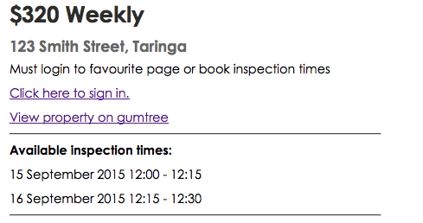

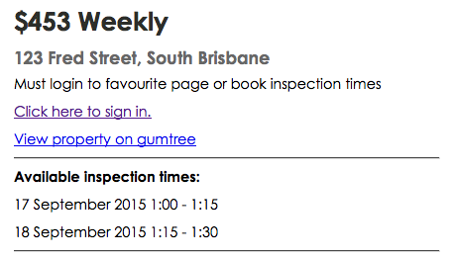

'1',NULL,NULL,NULL,'123 Smith Street','Taringa','3','unit','0','1','This house is a test, It features a number of different features.','320','http://www.gumtree.com.au/s-ad/beaumaris/flatshare-houseshare/large-beach-side-house-king-bed-ensuite-pool-view-transport-/1085277833','15 September 2015 12:00 - 12:15','16 September 2015 12:15 - 12:30','0'

'2',NULL,NULL,NULL,'123 Fred Street','South Brisbane','2','house','0','1','This house is a second test, It features a number of different features.','453','http://www.gumtree.com.au/s-ad/penshurst/flatshare-houseshare/double-room-for-rent-in-quiet-street-close-to-station/1084216095','17 September 2015 1:00 - 1:15','18 September 2015 1:15 - 1:30','0'

'3',NULL,NULL,NULL,'222 Smith Street','Taringa','2','unit','0','1','This house is a test1, It features a number of different features.','200',NULL,'16 September 2015 12:15 - 12:30','17 September 2015 12:15 - 12:30','0'

'4',NULL,NULL,NULL,'111 Beatrice Street','Taringa','1','unit','0','2','This house is a test2, It features a number of different features.','100',NULL,'17 September 2015 12:15 - 12:30','21 September 2015 12:15 - 12:30','0'

'5',NULL,NULL,NULL,'112 Beatrice Street','Taringa','2','house','1','3','This house is a test3, It features a number of different features. ','200',NULL,'18 September 2015 12:15 - 12:30','21 September 2015 12:15 - 12:30','0'

**Outcome**: Success, inspection time is correctly generating from database

**Test scenario:** Used Selenium to test that every time a search is used the inspection times are displayed appropriately.

**Expected outcome**: The test should return successfully

**Selenium Automation Test file:** viewinspectiontimes.html

**Selenium Automation result message:** [info] Test case passed

**Outcome**: Success

**Test scenario**: The inspection times are always displayed consistently with the rest of the page

**Expected outcome**: Inspections times should always be displayed correctly

**Results**:

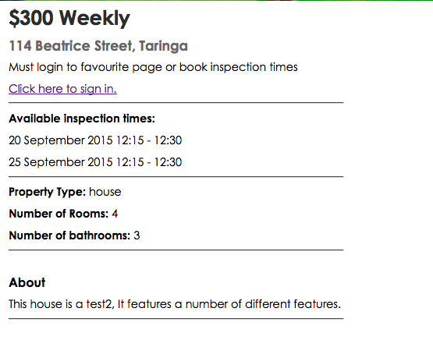

**Outcome**: Success, inspection times are consistently positioned on the page with the same formatting as the rest of the page.

**Story ID: 08 View personal property details**

**Test scenario**: Check that all property details are displayed clearly on the page with no errors.

**Expected outcome**: All property details are formatted correctly.

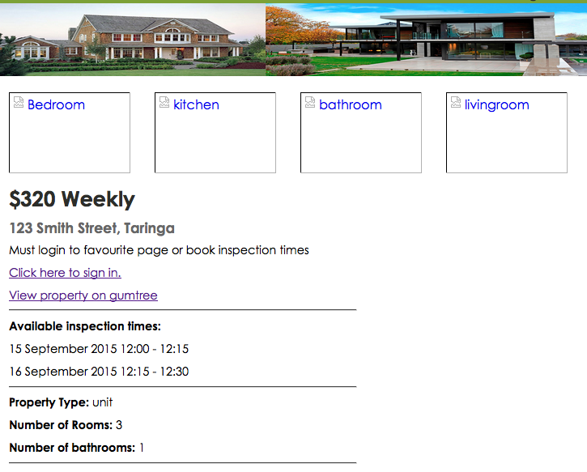

**Outcome**: Success, tested multiple pages and they were all formatted the same. (Images are broken due to temporary database changes.

Test scenario: Test that different features are available when logged in as a tenant. Ie favourite button.

**Expected outcome**: favourite button is available when signed in, and unavailable when not

**Selenium Automation Test file:** homepageffavourite.html,

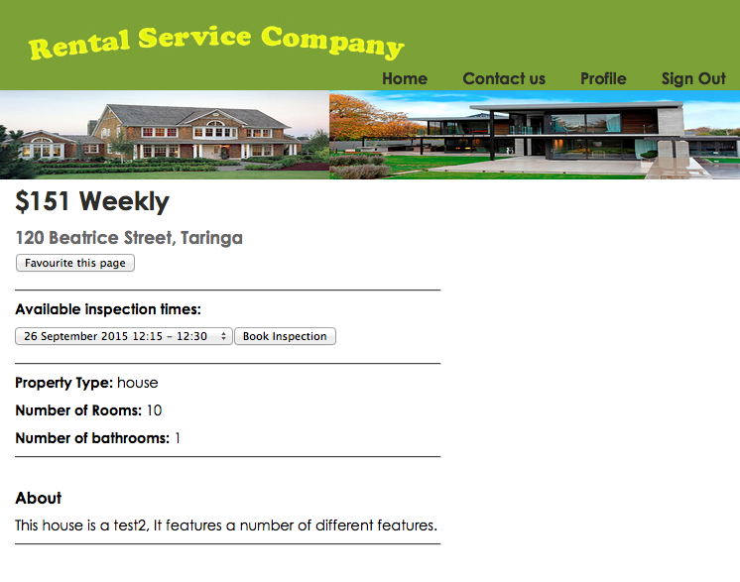

**Outcome**: [info] Test suite completed: 1 played, all passed! When the tenant is signed in.

**Test scenario**: Test that all images are formatted and displayed correctly.

**Expected outcome**: Photo layout is correct

**Response**:

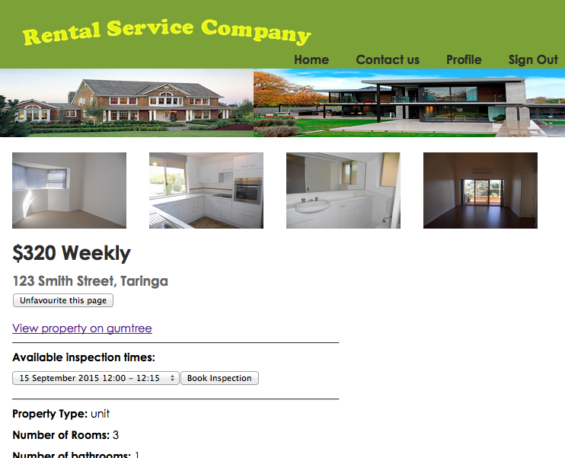

**Outcome**: Success

**Story ID: 18 Home Page**

**Test scenario**: Check that the home page has a clearly defined search option, and link to log in/registration.

**Expected outcome:** Both login/registration and the search function are formatted correctly.

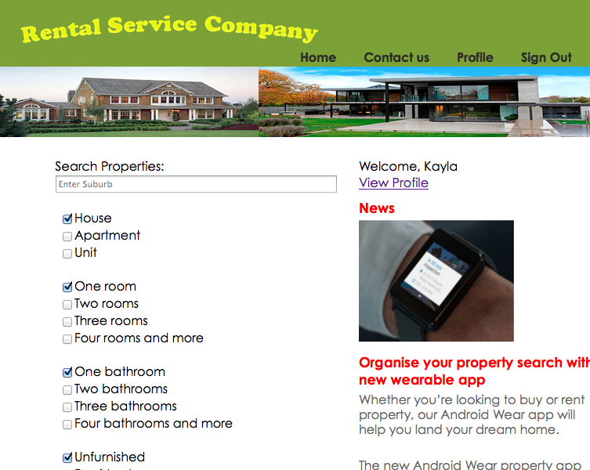

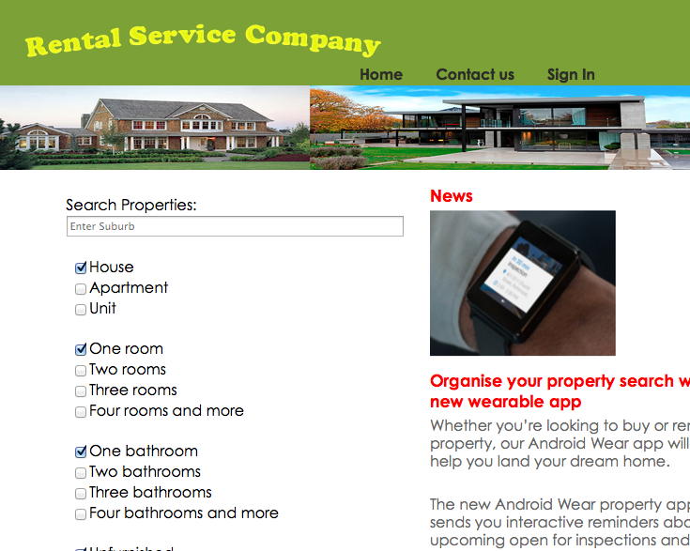

**Outcome**: Success, sign in/singout, search and profile links are available

**Test scenario**: No aspect of the home page can be edited/permanently modified by external users.

**Expected outcome**: When viewing the homepage users cannot edit the format or content

**Outcome**: Success, after several tests the home page was never permanently edited or changed.

**Test scenario**: Load the home page in a range of browsers (chrome, Internet Explorer, Mozilla Firefox, Safari)

**Expected outcome**: The homepage format remains the same and is accessible in all browsers.

Firefox:

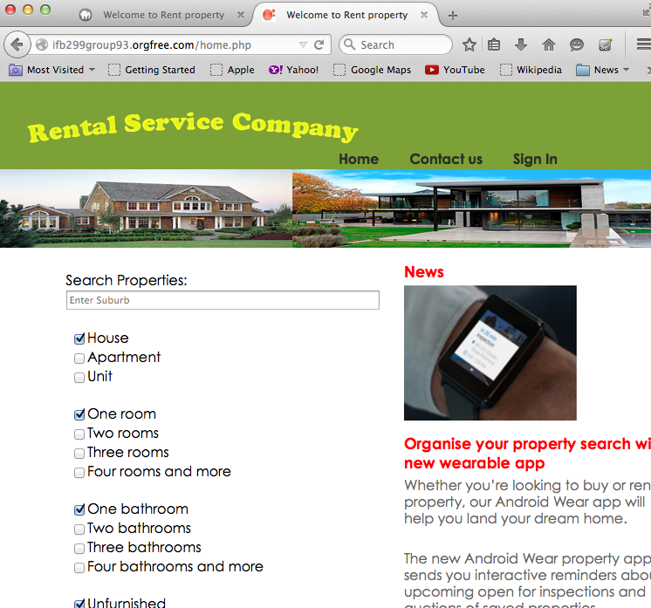

Chrome:

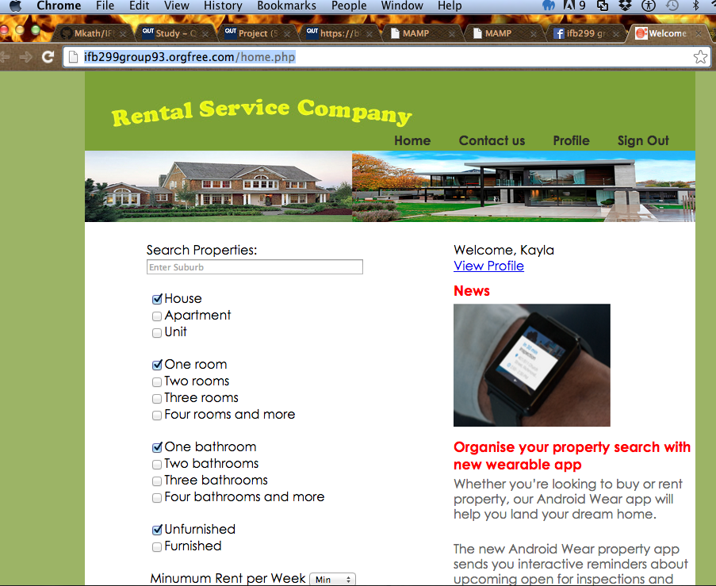

Safari:

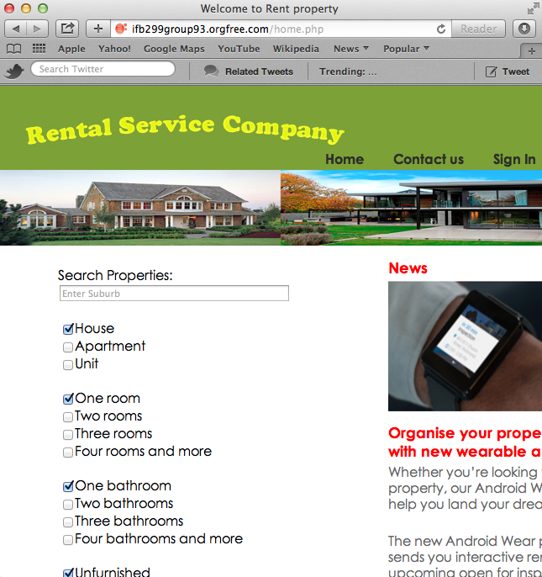

**Outcome**: Success

**Story ID: 10 Advertise on Gumtree**

**Test scenario**: Test that all properties have a house ID which can be used to find the house on the website.

**Expected outcome**: Every house has a property ID which can be added to the end of the website link to access the house properties page.

**Selenium Automation Test file:** propertyid.html

**Selenium Automation result message:**

• [error] false

• [info] Test case failed

Property ID is used for every property in defining its URL <http://ifb299group93.orgfree.com/properties_page.php?ID=4>

**Outcome**: Successfully identifies using ID numbers, possibly add property ID number to property description to ensure that the user can easily identify property ID.

**Test scenario**: Check that all properties with a Gumtree advertisement have a link to the Gumtree advertisement on their property details page, which is generated by pulling the information from the database. Test that all links are available and open successfully.

**Expected outcome**: Gumtree advertisement is available on properties page

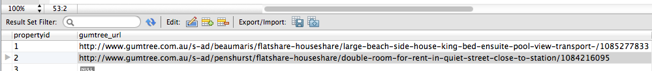

Property 1 has the correct link available:

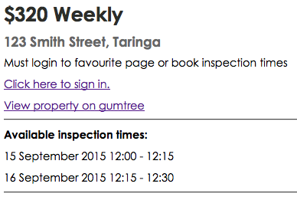

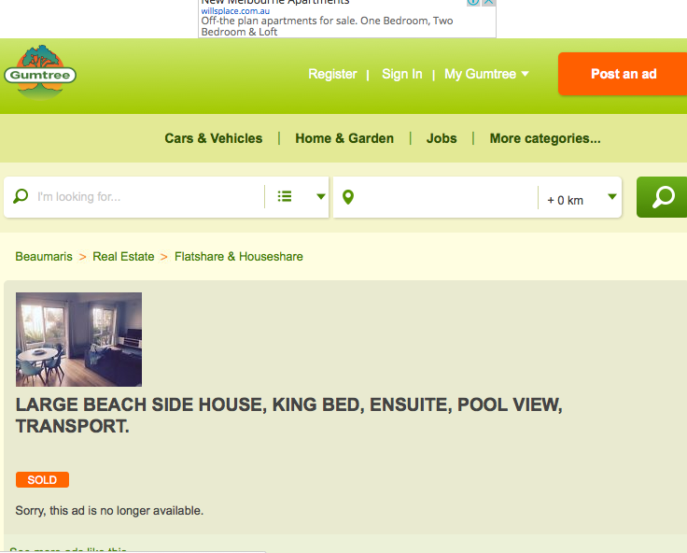

Property 2 has the correct link available:

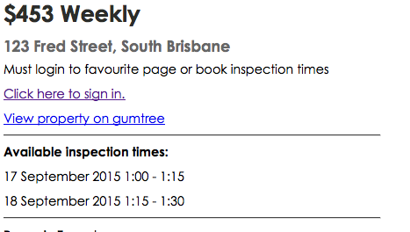

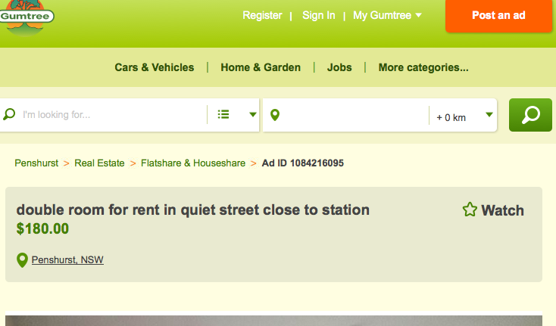

When there’s no gumtree link for the property the gumtree link is no longer available:

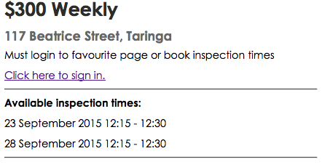

**Outcome**: Success

**Story ID: 04 Favourite properties:**

**Test scenario**: Test that the favourite button is available on every property if the tenant is signed in.

**Expected outcome**: every property has a favourite option when signed in.

**Selenium Automation Test file:** homepageffavourite.html

**Outcome**: Success

**Test scenario**: If the tenant is not logged in the favourite options should not be available.

**Expected outcome**: Favourite option should not be available

**Selenium Automation Test file:** nofavouritepage.html

**Selenium Automation result message:**

• [error] false

• [info] Test case failed

**Outcome**: Success, favourite option not available when tenant is not logged in.

**Test scenario**: That the favourited page is available on the tenant profile.

**Expected outcome**: All pages added to favourites are available.

**Selenium Automation Test file:** favouritepropertyavailable.html

**Selenium Automation result message:** [info] Test case passed

**Response**:

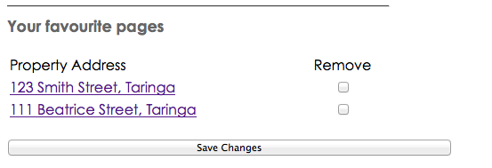

**Outcome**: Success

**Test scenario**: Test that tenant can remove a favourite property from the favourite page.

**Expected outcome:** Every favourite page should be available for removal.

**Selenium Automation Test file:** deletefavourites.html

**Selenium Automation result message:** Passed original [info] Executing: |verifyTextPresent | Property Address | |test when favourites are added, fails second test once the favourite is removed • [error] false

• [info] Test case failed.

**Response**: All favourite pages have the option for removal.

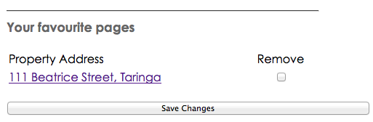

Once removed the favourite is no longer available.

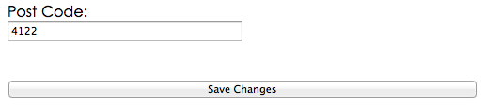

**Outcome**: Success